**INFO6205: Program Structure and Algorithms**

**Assignment 4 – Parallel Sort**

**By**

**Ajay Mohandas**

**NEU ID: 001426741**

# Observation

Scenario 1: To experiment and come up with a good value for this cut-off

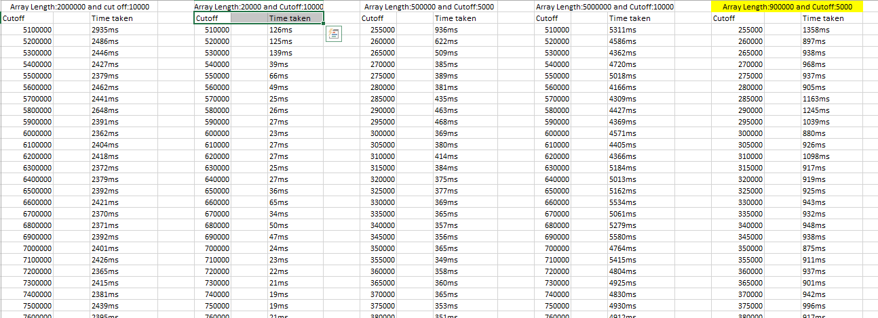

1. After considering range of array length from 20000 to 900000, for higher array length the cut-off value should also increases.
2. If the array length is less that the cut-off then Arrays.sort is implemented which takes time to sort the elements
3. If the array length is greater than cut-off then it goes into “else” condition to implement the CompletableFuture where two separated threads are created to sort elements parallel. Time taken to do parallel sorting is less compared to system sort.

Scenario 2: Decide on an ideal number (t) of separate threads

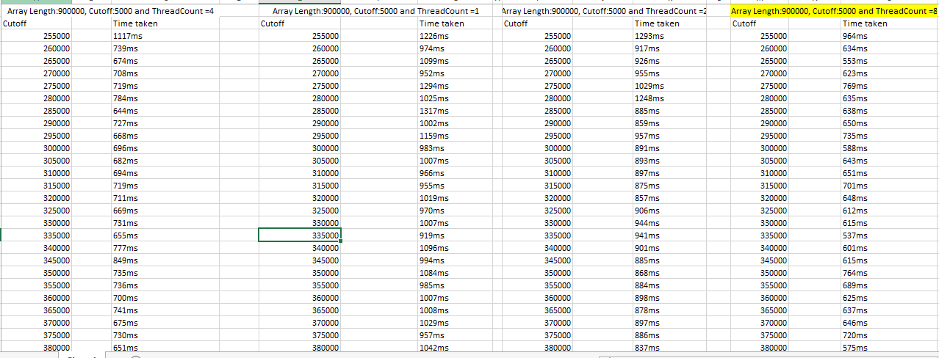

1. The default degree of parallelism is 3 and its observation is as mentioned in above screenshots.
2. If we reduce the number of worker threads, then time taken to sort the array increases.
3. If we increase the number of worker threads then time taken to sort the arrays reduces.

Note: The array length and cut-off value has kept constant from the scenario 1 analysis.

# Analysis

1. For scenario 1, after keeping the array length as 900000 and experimented various values for cut-off. The cut-off value 5000 give a stable time value for larger array length and smaller array length as well. Hence ideal cut-off value as per my observation is 5000
2. For scenario 2, various number of worker thread was considered and thread count 8 produces a stable value for larger array length. Time taken to sort a larger array length reduces with larger thread count.
3. As number of worker thread increases the time to parallel sort also reduces.

# Conclusion

**Parallelism** is the simultaneous execution of two or more tasks ForkJoin interface helps in parallel processing of sub task and combines result to one.

Using sorting algorithm like merge sort helps in parallel sorting since each worker thread sort a subset of array and combines the result to form a sorted array.